LAB 8
Title: Date and Time data types in SQL Objective:
• To be familiar with date and time data types and its implementation Theory:
MySQL comes with the following data types for storing a date or a date/time value in the database:
DATE - format YYYY-MM-DD
DATETIME - format: YYYY-MM-DD HH:MI:SS
TIMESTAMP - format: YYYY-MM-DD HH:MI:SS
YEAR - format YYYY or YY
TIME A time. Format: hh:mm:ss.

Commonly Used Date/Time Functions
- CURDATE()
This function is used to get the current date and time.
For example,
SELECT CURDATE();
Here, the function returns the current date and time.
- DATEDIFF(date_part, start_date, end_date)
This function is used to determine the difference between two dates. For example,
SELECT DATEDIFF(month, '2020-12-31', '2022-01-01 ');
-- output: 13
Here, the function returns the difference between the two dates in months.
The output 13 indicates that there's a difference of 13 months between 2020-12-31 and 2022-01-01 . we can similarly find the difference in terms of years, days etc.
Note: In MYSQL DATEDIFF() function has only two parameters.
DATEDIFF( end_date, start_date)
This returns the date difference in terms of number of days.

- TIMEDIFF()
The TIMEDIFF() function returns the difference between two time/datetime expressions.
Note: time1 and time2 should be in the same format, and the calculation is time1 - time2.
Syntax
TIMEDIFF(time1, time2)
Note:
Here, in DATDIFF() function we have passed two parameters that is

DATEDIFF( date1, date2)

This will returns date difference in terms of number of days (date1-date2)

This is for if we run query on MySQL DBMS.

But sometimes it is necessary to find out date difference in terms of number of month, week, year, quarter etc. In such case three parameters need to passed three parameters.
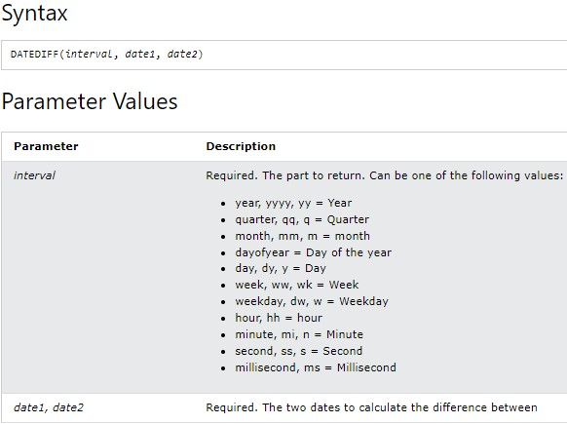
Note:
  - DATEDIFF() function with two parameters are supported in MYSQL DBMS.
  - DATEDIFF() function with three parameters are supported in MS SQL Server DBMS

